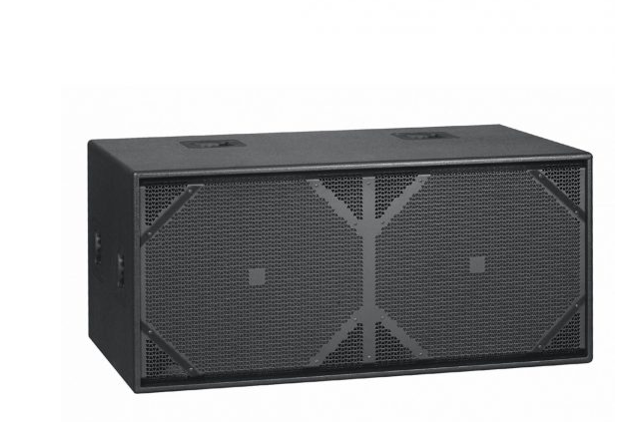

SL 218
EVP/SRP*:
*empfohlener Verkaufspreis / Suggested Retail Price
Passive subwoofer, 2x 2000 W (Peak), 2x 4 ohms, 2x 18″, 132 dB max. SPL, 39 Hz–130 Hz (+/-3 dB), 4x Speakon NL4
Merkliste
E-Mail

- Description

- Techn. Data

- Downloads

Techn. Data

SL 218
Product Class | Concert Sound
Power-handling nominal (RMS) | 2x 1000 W
Power-handling, peak | 2x 2000 W
Maximum SPL, @ 10% THD | 132 dB @ 10% THD (half space)
Sensitivity 1W/1m | 105 dB
Frequency response +/- 3 dB | 39 Hz - 130 Hz
Frequency response -10 dB | 30 Hz - 130 Hz
LF Speaker | 2x 18"
Crossover frequency | 60 Hz - 100 Hz, 12 dB bzw. 24 dB / oct.
Connections | 4x Speakon NL4
Handles | 6, integrated
Casters | 4x 100 mm
Enclosure | Birch plywood 18mm, 13- ply
Grille | Heavy-duty metal grille
Finish | Black polyurethane lacquer
Dimensions (WxHxD) | 120 cm x 56 cm x 79 cm (castors included)
Weight | 88 kg / 193.6 lbs.

