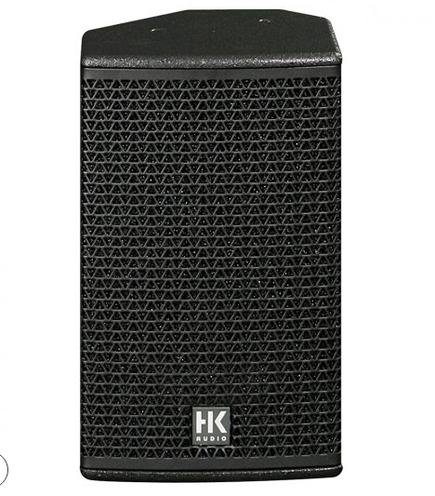

CT 108
EVP/SRP*:
*empfohlener Verkaufspreis / Suggested Retail Price
Passive, 800 W (peak), 8″/ 1″ (90° x 55° rotatable CD horn), 128 dB max. SPL, 90 Hz – 19 kHz, 2 x Speakon NL4
Merkliste
E-Mail

- Description

- Techn. Data

- Accessories

- Downloads

Description
CT 108 – FIRST CLASS WORKING HORSE
The CT 108 is an extremely compact, passive public address / full-range speaker cabinet. Featuring a dual-purpose housing, it may be employed as an FOH or delay speaker as well as a stage monitor. It is an excellent choice for rendering the human voice and acoustic instruments. Hallmark features include superb intelligibility, extraordinary phase linearity and wide dynamic range. The CT 108 is available in left and right versions. In combination with a CT 118 subwoofer, it also serves as a small club system. The CT 108 may be operated with or without a controller. For the best audio results, the use of an HK AUDIO DSM 2060 Controller or HK AUDIO Digital Field Controller is recommended.
Application scenarios: Distributed (public address) sound reinforcement, playback or instrument monitor in theaters and for orchestras, and as an FOH mid/high-range unit for smaller club gigs.
- Power Capacity RMS/program/peak: 200/400/800 watts
- Sensitivity 1W@1m (Half Space): 101 dB
- Max. SPL peak (Half Space): 129 dB
- Frequency response +/-3 dB: 100 Hz – 19 kHz

