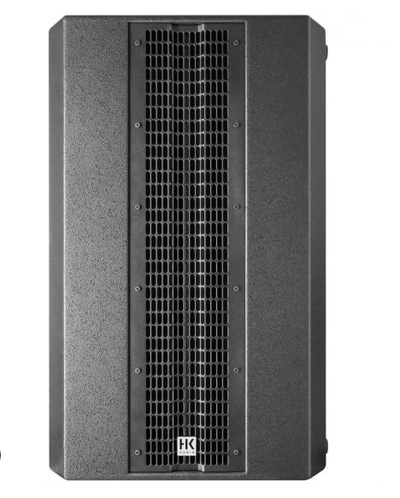

L SUB 2000

EVP/SRP*:
*empfohlener Verkaufspreis / Suggested Retail Price
Passive subwoofer, 1200W program, 2x 12”, 2.5 ” voice coil, 135 dB max. SPL, birch plywood, M 20 threading, 2 x Speakon NL 4
Merkliste
E-Mail

- Description

- Techn. Data

- Accessories

- Downloads

Description

L SUB 2000 – A LOW-END BOOST FOR THE LINEAR SERIES
Equipped with a sixth-order double bandpass crossover, the Linear SUB 2000 provides the perfect bass reinforcement for L5 mid/ high units. Its low-end performance in the 50-120 Hz range is most impressive. It sports two 12″ high-excursion woofers featuring a 2.5″ voice coil with a state-of-the-art cooling system and a dual spider suspension to keep it perfectly centered.
- High-power system subwoofer for rental companies
- Power handling (continuous): 700 Watts (2800 W Peak)
- 2 x 12″ speakers with 2.5″ voice coil
- 133 dB Max SPL Peak @ 10% THD (halfspace)
- Rugged birch multiplex wooden enclosure
- Integrated HK Audio MultiGrip handles
- Ideal add-on to LINEAR 5 mid/high units

