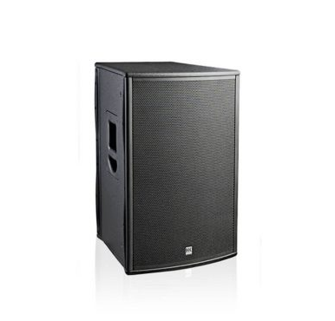

PL 115 FA
EVP/SRP*:
*empfohlener Verkaufspreis / Suggested Retail Price
This product from our product archive is no longer available to order.
This product is not currently available.

Merkliste
E-Mail

- Description

- Downloads

Description
An active cabinet loaded with a 15” woofer, the Pulsar PL 115 FA features a muscular 1,000-watt power amp and an input section sporting three inputs. Although much the same size and weight as the PL 112 FA, the PL 115 FA offers added headroom for the bass frequencies and low mids. With its impressive dynamic range, it is able to provide a rock-solid bass foundation even at high volume levels. And that makes it an excellent standalone solution and the perfect complement to the PL 118 Sub A subwoofer in larger setups. HK Audio also offers an extensive set of accessories for flown and monitoring applications as well as dust covers and Tilt Units.
- Amazing bass response even at high volume levels
- Remarkably balanced sound on its own and with a sub
- Impact-resistant epoxy strips to protects edges
- Wood housing for optimum acoustics
- Extensive DSP functions
- Three inputs for utmost versatility
- Optional rigging & monitor accessories, Tilt unit
- Five-year warranty
- Made in St. Wendel, Germany

