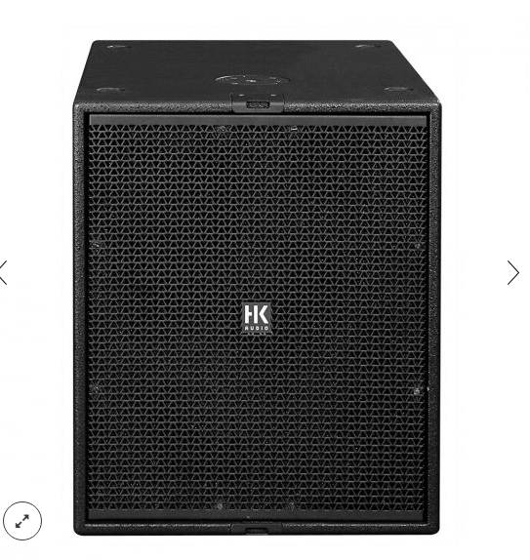

CT 118 SUB
EVP/SRP*:
*empfohlener Verkaufspreis / Suggested Retail Price
Passive, 4,000 W (peak), 18″, 131 dB max. SPL, 32 Hz – 350 Hz, 2 x Speakon NL4
Merkliste
E-Mail

- Description

- Techn. Data

- Downloads

Description
CT 118 Sub – FIRST CLASS WORKING HORSE
The CT 118 Sub is a direct-radiating bass reflex subwoofer designed for use in active sound reinforcement systems. It was developed specifically for deployment in combination with the HK AUDIO ConTour Series™ cabinets CT 108, CT 112 and CT 115. Loaded with a neodymium woofer, the CT 118 Sub is extremely compact and lightweight. Delivering uniform bass response, it renders impulses with accuracy and authority even at peak loads. The CT 118 Sub is the perfect choice of bass bin for high-performance front-of-house systems and drum/side fills.
The CT 118 Sub can be retrofitted with an optional passive crossover. The passive crossover is equipped with true low-pass and high-pass filters for the sake of configuring basic satellite systems without having to resort to extra power amps or active crossovers. This makes it the ideal no-hassle option for enhancing lowend response.
For maximum performance, it is recommended that this enclosure be operated with an HK AUDIO DSM 2060™ Controller or an HK AUDIO Digital Field Controller™ (DFC) in combination with a DFC network. Application scenarios: Low-frequency enhancement for setups entailing CT 108, CT 112 and CT 115 speakers.
- Power Capacity RMS/program/peak: 1000/2000/4000 watts
- Sensitivity 1W@1m (Half Space): 100 dB (50Hz – 200 Hz)
- Max. SPL peak (Half Space): 131 dB
- Frequency response +/-3 dB: 41 Hz – 350 Hz

