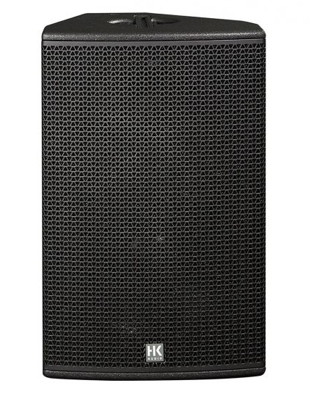

CT 115
EVP/SRP*:
*empfohlener Verkaufspreis / Suggested Retail Price
Passive, 2,400 W (peak), 15″/ 1.4″ (60° x 40° rotatable CD horn), 134 dB max. SPL, 55 Hz – 19 kHz, 2 x Speakon NL4
Merkliste
E-Mail

- Description

- Techn. Data

- Accessories

- Downloads

Description
CT 115 – FIRST CLASS WORKING HORSE
The CT 115 is a passive speaker cabinet that may also be configured in biamp mode. Offering an extended lowfrequency range and featuring a dual-purpose housing, it can serve as a FOH speaker as well as a stage monitor. The CT 115’s hallmarks include speech intelligibility, extraordinary phase linearity, and wide dynamic range. Its HF horn has been optimised using the BEM (Boundary Element Method) for precise directivity and optimal clustering without phase cancellation.
The CT 115 was developed principally for full-range sound reinforcement applications over short to medium-throw distances, without an additional subwoofer. When used as a stage monitor (Shape switch set to Monitor), the CT 115 cuts through even on loud stages and is able to handle kick drum and bass signals. The CT 115 is available in left and right versions for balanced monitoring arrangements. The HK AUDIO CT 118 Sub is the recommended enhancement for setting up powerful, two-way active systems.
The CT 115 may be operated in passive or biamp mode with or without a controller. For the best audio results, it is recommended that this enclosure be operated with the HK AUDIO DSM 2060 Controller or HK AUDIO Digital Field Controller (DFC) in combination with a DFC network.
Application scenarios: Stand-alone fullrange system, near-field sound reinforcement for applications demanding high SPL, for example, as an FOH mid/ high-range unit in live clubs, an ancillary front fill for COHEDRA™ systems, a mid/high-range unit for side or drum fills and for monitoring on larger stages.
- Power Capacity RMS/program/peak: 600/1200/2400 watts
- Sensitivity 1W@1m (Half Space): 106 dB
- Max. SPL peak (Half Space): 138 dB
- Frequency response +/-3 dB: 65 Hz – 16 kHz

