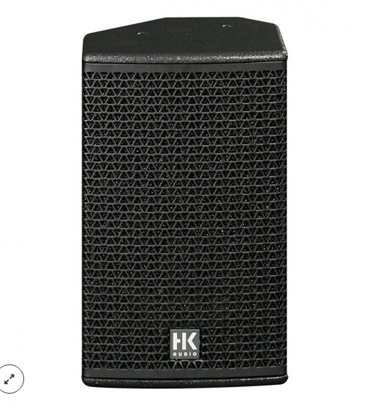

CT 112
EVP/SRP*:
*empfohlener Verkaufspreis / Suggested Retail Price
Passive, 1,800 W (peak), 12″/ 1.4″ (60° x 40° rotatable CD horn), 134 dB max. SPL, 65 Hz – 19 kHz, 2 x Speakon NL4
Merkliste
E-Mail

- Description

- Techn. Data

- Accessories

- Downloads

Description
CT 112 – FIRST CLASS WORKING HORSE
The CT 112 is a passive speaker cabinet that may also be configured in biamp mode. Featuring a dualpurpose housing, it can serve as a FOH speaker as well as a stage monitor. The CT 112’s hallmarks include speech intelligibility, extraordinary phase linearity, and wide dynamic range. Its HF horn has been optimised using the BEM (Boundary Element Method) for precise directivity and optimal clustering without phase cancellation. Due to its low-profile housing, it is also an outstanding option for demanding stage monitoring applications. The Shape switch on its rear panel reconfigures and optimises the CT 112 crossover to satisfy the different requirements of FOH and monitor applications. The CT 112 is available in left and right versions for symmetrical monitoring. The HK AUDIO CT 118 Sub subwoofer is the recommended enhancement for setting up powerful, two-way active systems. The CT 112 may be operated in passive or biamp mode with or without a controller. For the best audio results, it is recommended that this enclosure be operated with the HK AUDIO DSM 2060 Controller or HK AUDIO Digital Field Controller (DFC) in combination with a DFC network.
Application scenarios: Full-range public address, nearfield sound reinforcement for applications demanding high SPL, for example, as an FOH mid/high-range unit in live clubs, an ancillary front fill for COHEDRA™ systems, a mid/high-range unit for side or drum fills and for monitoring on larger stages.
- Power Capacity RMS/program/peak: 400/800/1800 watts
- Sensitivity 1W@1m (Half Space): 107 dB
- Max. SPL peak (Half Space): 138 dB
- Frequency response +/-3 dB: 80 Hz – 16 kHz

