PX128
Power Sequencer

Product Description:  The PX128 is a 1U Power Sequencer  Key Features and Benefits:  - At power on there is a 1 second delay start time between channels - reverse is true in power down mode  - Front Panel  Independent channel one touch power switch  Single bypass switch  Single all off power switch  - Rear Panel  8 x power output connectors  6.5mm link connectors  Front Panel:  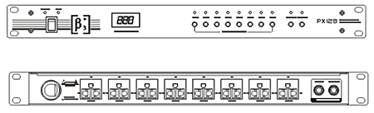
  Specifications
  System max power output (RMS) | 18KW
  System max power output (RMS)  Channel’s max power output (RMS) | 3KW
  Connect/Disconenct Delay Time | 1s
  Network Connection Control | have
  Bypass Function | have
  Operating Voltage | 220V 50Hz-60Hz
  Dimensions (W x D x H) | 483mm (19”) x 222mm (8.7”) x 45mm (1.8”)
  Packaging Dimensions (1 piece/pack) | 555mm (21.9”) x 310mm (12.2”) x 78mm (3.1”)
  Net Weight (1 piece/pack) | 5kg (11lb)
  Gross Weight (1 piece/pack) | 6kg (13.2lb)
  Mouseover image to zoom
  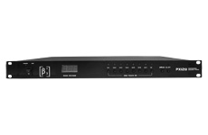
  Front View Back View

