DS1800
Signal Distributor

Product Description:  The DS1800 is a 1U, 2 in 4 out, or 1 in 8 out Distribution Amplifier.  Key Features and Benefits:  - Front Panel  Independent volume control to adjust each channel (concealed controls)  LED indicator for mode selection  LED signal indicators\  - Rear Panel  2 x Balanced XLR input connectors  8 x Balanced XLR output connectors  2 x XLR link connectors  Mode switch for 2 x 4 or 1 x 8  Panel:  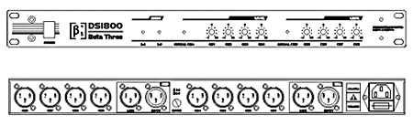
  Specifications
  Input Connector | 2 x Balanced XLR
  Input Impedance | 8 x Balanced XLR, 2 x Balanced XLR Link
  Maximum Output Levels | Balanced 10kΩ
  Max.Output Level | ≥ + 20dB
  Frequency Response (±0.3dB) | 20Hz-20kHz
  THD + N | <0.008%
  S/N Ratio (A weight) | >100dB
  Dynamic Range | ≥ 115dB
  Power Consumption | <8W
  Power Supply | 220V 50Hz
  Dimensions (W x D x H) | 483mm (19”) x 172mm (6.8”) x 45mm (1.8”)
  Net Weight (1 piece/pack) | 2.5kg (5.5lb)
  Gross Weight (1 piece/pack) | 3.5kg (7.7lb)
  Mouseover image to zoom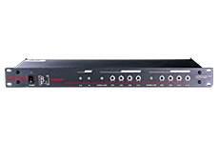
  Front View Back View

