U8
8” Two Way Full Range Plastic Speaker

Product Description:  Portable and installed plastic loudspeakers used in applications including sound reinforcement in Front of House and Foldback applications in Houses of Worship,Events, Clubs, Rehearsal Halls etc. The U Active Series delivers extraordinary performance at unmatched value.  Features:  - High output SPL and sensitivity  - 1 x 8” high power transducer with 50mm voice coil  - 1 x 1.3” diaphragm compression driver  - 90º x 60º controlled coverage pattern  - Rotatable Horn  - Heavy duty protective grill  - Injection molded  - 1 x NL4 connector  - Cabinet design for FOH and Monitor use  - Suitable for use as a main system with or without sub speaker augmentation  - Portable system (stand), or permanent installation (wall, ceiling, under balcony)  - Arrays with all active high power U Series sub speakers for extended low  frequency, high quality music reproduction  - Monitor kit - optional  Cabinet Dimension:  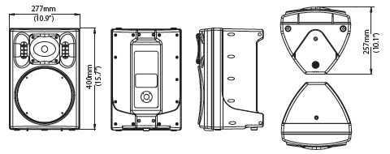  Installation drawing:  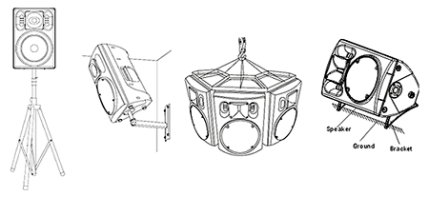
  Specifications
  Construction | Plastic
  Transducers | 1 x 1.3” HF + 1 x 8” LF
  Frequency Response (-3dB) | 65Hz-18kHz
  Rated Power | 100W (RMS)
  Sensitivity (1W @ 1m) | 92dB
  Maximum SPL (1W @ 1m) | 111dB (Peak)
  Rated Impedance | 8Ω
  Dispersion (HxV) | 90°x60°
  Connector | 1xNL4
  Dimensions (WxDxH) | 277mm (10.9”) x 257mm (10.1”) x 400mm (15.7”)
  Packaging Dimensions (1 pair/pack) | 595mm (23.4”) x 310mm (12.2”) x 600mm (23.6”)
  Net Weight (1 piece/pack) | 6.5kg (14.3lb)
  Gross Weight (1 pair/pack) | 15kg (33.1lb)
  Mouseover image to zoom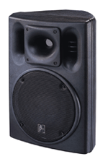
  Relevant Download:
  U Series Catalog
  User Manual
  U8 Image

