U15
15” Two Way Full Range Plastic Speaker

Product Description:  Portable and installed plastic loudspeakers used in applications including sound reinforcement in Front of House and Foldback applications in Houses of Worship,Events, Clubs, Rehearsal Halls etc. The U Active Series delivers extraordinary performance at unmatched value.  Key Features and Benefits:  - High output SPL and sensitivity  - 1 x 15” high power transducer with 50mm voice coil  - 1 x 1.7” diaphragm compression driver  - Rotatable Horn: 50º-100º x 55º controlled coverage pattern  - Heavy duty protective grill  - Injection molded  - 2 x NL4 connector  - Cabinet design for FOH and Monitor use  - Suitable for use as a main system with or without sub speaker augmentation  - Portable system (stand), or permanent installation (wall, ceiling)  - Arrays with all active high power U Series sub speakers for extended low frequency, high quality music reproduction  - Monitor kit - optional  Cabinet Dimension:  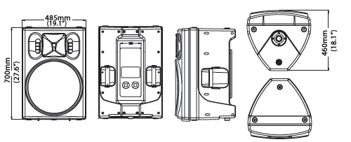  Installation drawing:  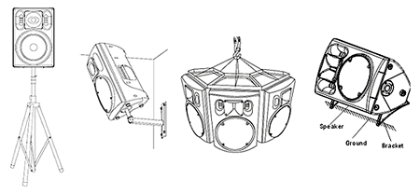
  Specifications
  Construction | Plastic
  Transducers | 1 x 1.7” HF + 1 x 15”LF
  Frequency Response (-3dB) | 40Hz-18kHz
  Rated Power | 300W(RMS)
  Sensitivity (1W @ 1m) | 98dB
  Maximum SPL (1W @ 1m) | 121dB(Peak)
  Rated Impedance | 8Ω
  Dispersion (H x V ) | 50°-100°x55°
  Connector | 2xNL4
  Dimensions (W x D x H) | 485mm(19.1”)x460mm(18.1”)x700mm(27.6”)
  Packaging Dimensions (1 piece/pack) | 545mm(21.5”)x515mm(20.3”)x800mm(31.5”)
  Net Weight (1 piece/pack) | 26kg(57.3lb)
  Gross Weight (1 piece/pack) | 28kg(61.7lb)
  Mouseover image to zoom
  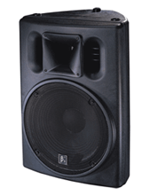
  Relevant Download:
  U Series Catalog
  User Manual
  U15 Image

