U6
6” Two Way Full Range Plastic Speaker

Product Description:  Portable and installed plastic loudspeakers used in applications including sound reinforcement in Front of House and Foldback applications in Houses of Worship,Events, Clubs, Rehearsal Halls etc. The U Active Series delivers extraordinary performance at unmatched value.  Key Features and Benefits:  - High output SPL and sensitivity  - 1 x 6” high power transducer with 50mm voice coil  - 1 x 1” diaphragm compression driver  - 90º x 60º controlled coverage pattern  - Rotatable Horn  - Heavy duty protective grill  - Injection molded  - 1 x NL4 connector  - Cabinet design for FOH and Monitor use  - Suitable for use as a main system with or without sub speaker augmentation  - Portable system (stand), or permanent installation (wall, ceiling, under balcony)  - Arrays with all active high power U Series sub speakers for extended low  frequency, high quality music reproduction  - Monitor kit - optional  Cabinet Dimension:  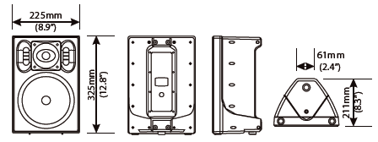  Installation drawing:  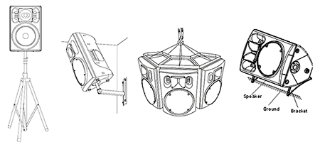
  Specifications
  Construction | Plastic
  Transducers | 1 x 1” HF + 1 x 6.5” LF
  Frequency Response (-3dB) | 80Hz-18kHz
  Rated Power | 80W (RMS)
  Sensitivity (1W @ 1m) | 91dB
  Maximum SPL (1W @ 1m) | 110dB (Peak)
  Rated Impedance | 8Ω
  Dispersion (H x V ) | 90° x 60°
  Connector | 1 x NL4
  Dimensions (W x D x H) | 225mm (8.9”) x 211mm (8.3”) x 325mm (12.8”)
  Packaging Dimensions (1 pair/pack) | 380mm (15”) x 255mm (10”) x 480mm (18.9”)
  Net Weight (1 piece/pack) | 5.6kg (12.3lb)
  Gross Weight (1 pair/pack) | 13.2kg (29.1lb)
  Mouseover image to zoom
  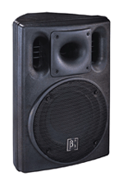
  Relevant Download:
  U Series Catalog
  User Manual
  U6 Image

