X15i
15” Two-Way Full Range Speaker

Product Description:  The X15i is a high performance live and portable sound reinforcement speaker for use in Night Clubs, Houses of Worship, Events, Clubs, Rehearsal Halls and Ballrooms etc. The Xi Series delivers extraordinary performance at unmatched value.  Key Features and Benefits:  - Very high output SPL and sensitivity  - 1 x 15” high power transducer  - 1 x 3” HF magnalium compression driver  - 60º x 60º coverage pattern  - 2 x NL4 connectors  - Computer aided design to optimise frequency and phase response  - Cabinet design for FOH use  - Suitable for use as a main system with or without sub speaker augmentation  - Can be arrayed with other boxes  - Arrays with any high Beta Three® high powered subwoofer speaker  - Powder coated grill  - Durable Polyurethane textured base paint  - For optimum performance use with a Beta Three® a digital speaker management processor  - 2 x NL4 connectors included in packaging  Cabinet Dimension:  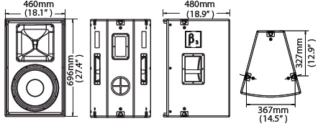  Installation drawing:  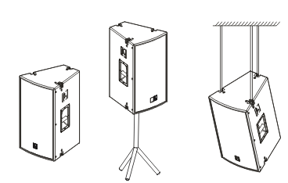
  Specifications
  Construction | 15mm Birch Plywood
  Transducers | 1 x 3” HF Compression Driver + 1 x 15” LF
  Crossover | 1.5kHz
  Frequency Response (-3dB) | 40Hz-16kHz
  Rated Power | 500W (RMS)
  Sensitivity (1W @ 1m) | 95dB
  Rated Impedance | 8Ω
  Dispersion (H x V ) | 60° x 60°
  Connector | 2 x NL4
  Dimensions (W x D x H) | 480mm (18.9”) x 460mm (18.1”) x 696mm (27.4”)
  Packaging Dimensions (1 piece/pack) | 590mm (23.2”) x 570mm (22.5”) x 816mm (32.2”)
  Net Weight (1 piece/pack) | 37.5kg (82.5lb)
  Gross Weight (1 piece/pack) | 40kg (88lb)
  Mouseover image to zoom
  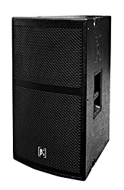
  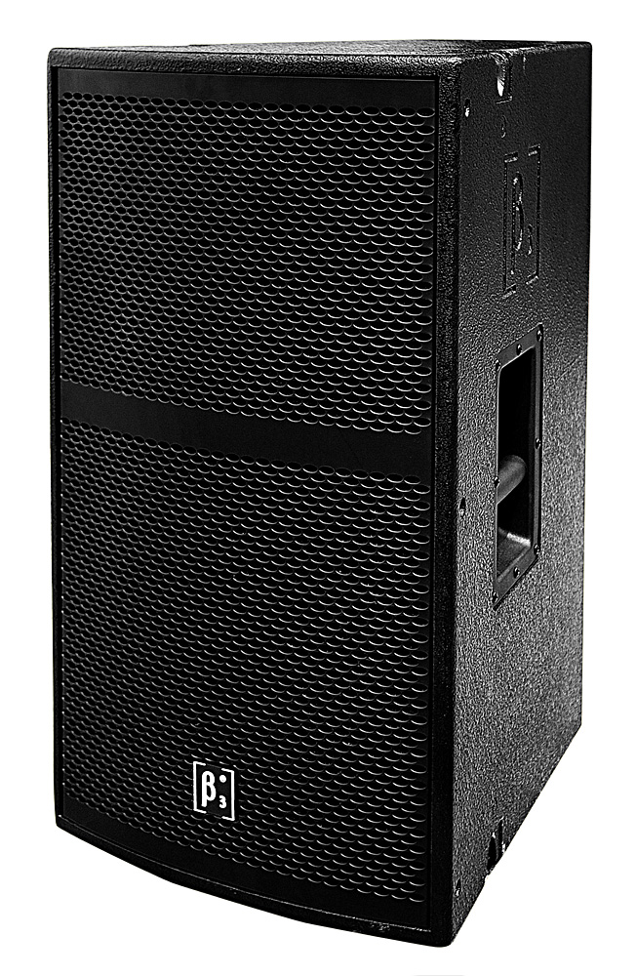
  Front Back Bottom
  Relevant Download:
  User Manual
  X15I Image

