A8
Stereo Amplifier

Product Description:  The A Series 2U professional amplifiers have been engineered for reliability where full power is required for extended times in fixed installations or portable applications. The A Series delivers extraordinary performance at unmatched value.  Key Features and Benefits:  - Housed in a rugged, all-steel 2U chassis  - 2 x convenient front panel carry handles  - Rear panel selection switch for Stereo, Parallel and Bridged modes, including Low-cut filter, Ground lift and Limiter switches  - Operates within 8Ω and 4Ω loads  - Innovative heatsink with front to back air flow for efficient cooling  - Variable fan speed is automatically adjusted by temperature  - Electronically balanced XLR inputs  - Touch proof binding post and Speakon outputs  - Precision indented level controls, power switch  - Protect, Peak and Signal LEDs indicators for each channel  - Amplifier protection includes short circuit, excessive temperature, and DC on outputs  Front Panel:  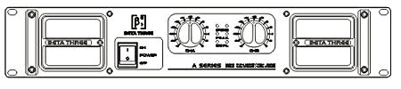  Rear Panel:  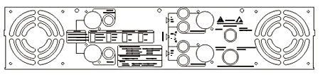
  Specifications:
  Rated Power (Stereo 8Ω) | 2 x 1000W
  Rated Power (Stereo 4Ω) | 2 x 1600W
  Rated Power (Bridge 16Ω) | 2000W
  Rated Power (Bridge 8Ω) | 3200W
  Rated Power (Parallel mono 8Ω) | 1000W
  Rated Power (Parallel mono 4Ω) | 1600W
  Input Sensitivity | 1V
  S/N Ratio (A Weight) | >108dB
  Frequency Response (+0/-0.25dB) | 20Hz-20kHz
  Damping Factor | >800 @ 8ohm/100Hz
  THD (10% Rated Power) | <0.05%
  Input Connector | 2 x XLR, 2 x 6.5mm TRS
  Input Impedance | 20kΩ Balanced, 10kΩ Unbalanced
  Output Connectors | 2 x NL4 + 4 x Binding post
  Cooling | 4 x fans, airflow from front to back
  Power Supply | 220V-230V 50/60Hz, 1500VA
  Dimensions (W x D x H) | 483mm (19”) x 452mm (17.8”) x 88mm (3.5”)
  Packaging Dimensions (1 piece/pack) | 550mm (21.7”) x 540mm (21.3”) x 175mm (6.9”)
  Net Weight (1 piece/pack) | 30kg (66.1lb)
  Gross Weight (1 piece/pack) | 32kg (70.5lb)
  Mouseover image to zoom
  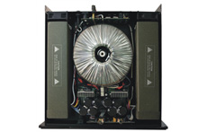
  Front View Back View Planform
  Relevant Download:
  User Manual
  A8 Image

